This document provides the necessary instructions for completing the Week 9 lab exercises.

Exercise 1: Trees

For the tree given in the Figure 8.3, answer to the following questions:

- Which node is the root?
- What are the internal nodes?
- How many descendants does node cs016/ have?
- How many ancestors does node cs016/ have?
- What are the siblings of node homeworks/?
- Which nodes are in the subtree rooted at node projects/?
- What is the depth of node papers/?
- What is the height of the tree?

Exercise 2: Tree traversal

For the following trees:
- Provide the output of the preorder traversal manually.
- Draw the output of the postorder traversal manually.

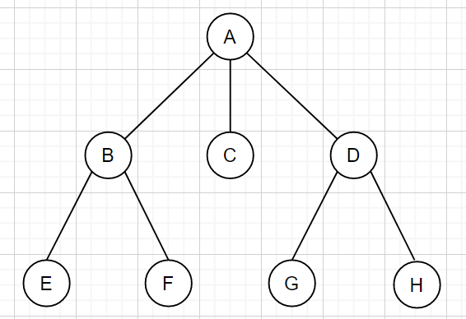 | 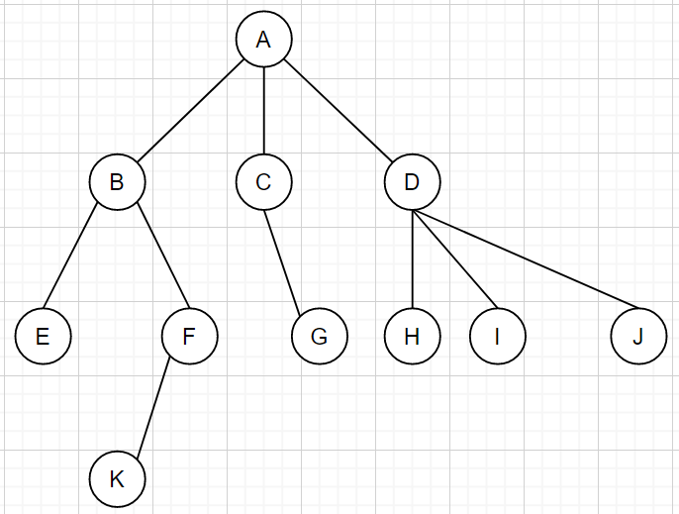

Exercise 3: Binary Trees

Which of the following binary tress is proper:

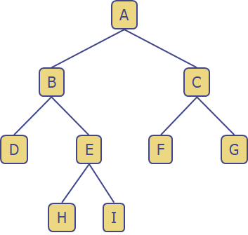 | 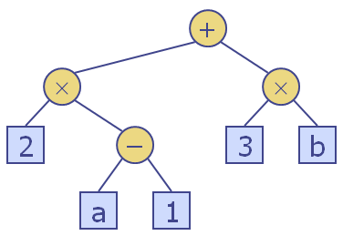
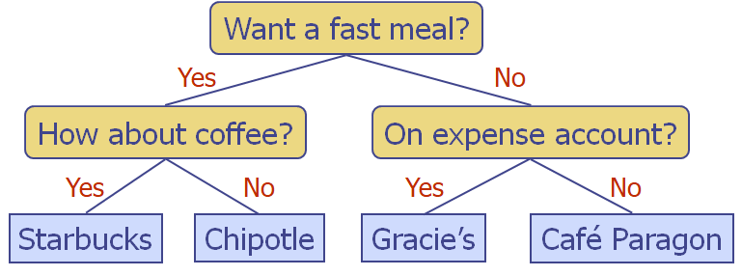 | 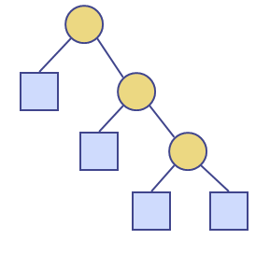
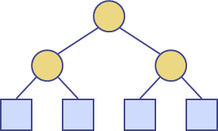 | 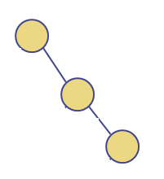

Exercise 4: Binary Trees – traversal

For the following binary trees, provide the output of the inorder traversal (manually):

 | 

Exercise 5: Binary Trees – Java implementation

In the array-based implementation of a binary tree, a node v is stored in an array A at A[rank(v)], using the following algorithm:
- If v = root, rank(root) = 0
- If node is the left child of parent(node), rank(node) = 2 * rank(parent(node)) + 1
- If node is the right child of parent(node), rank(node) = 2 * rank(parent(node)) + 2

See the picture below and write and test a Java method to implement this algorithm.
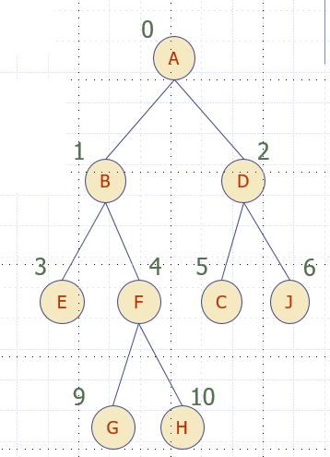 | 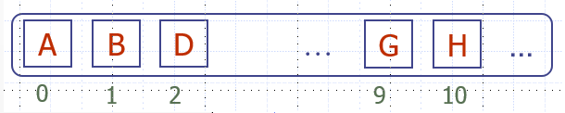

Your method should take as input a node from the above binary tree, calculate its rank and place it in the array A.
Exercise 6: Binary Trees – Java implementation

In the main method of LinkedBinaryTree class, implement the following:
- Create a LinkedBinaryTree for the binary tree below:
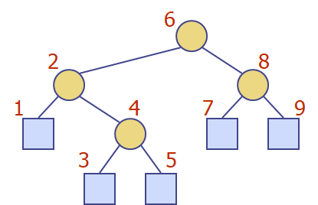
- Perform a preorder traversal of this linked binary tree and display the results.
- Perform an inorder traversal of this linked binary tree and display the results.
- Perform a postorder traversal of this linked binary tree and display the results.
- Perform a breadth-first traversal and display the results.

